Springfield Timetables
Elementary School | 08:30 | - | - | - | - | - | - | - | 22:10
Moe’s Tavern | 08:50 | 09:30 | 11:00 | 13:00 | 14:30 | 15:!5 | 18:00 | 20:30 | 22:30
Nuclear Power Plant | - | 10:05 | 11:35 | 13:35 | 15:05 | 15:50 | 18:35 | 21:05 | 23:05
Kwik-E-Mart | 09:40 | - | 11:55 | 13:55 | - | - | 18:55 | 21:25 | 23:30
Springfield Mall | 09:55 | - | - | 14:05 | - | - | - | - | -
Shelbyville | 10:15 | 10:45 | 12:45 | 14:25 | 15:45 | 16:30 | 19:40 | 22:35 | -
Shelbyville | 8:45 | 9:45 | 10:45 | - | - | 13:25 | - | 16:45 | -
Springfield Mall | 9:05 | 10:05 | 11:05 | - | 11:40 | - | 15:40 | 17:05 | 19:40
Kwik-E-Mart | 9:20 | 10:20 | 11:20 | - | 11:55 | - | 15:55 | 17:20 | 19:55
Nuclear Power Plant | - | - | - | 11:55 | 12:15 | 13:55 | 16:15 | - | 20:15
Moe’s Tavern | 10:10 | 11:10 | 12:10 | 12:30 | 12:45 | 14:30 | 16:45 | 17:10 | 20:45
Elementary School | 10:30 | 11:30 | 12:30 | - | 13:00 | 14:45 | 17:00 | 17:30 | 21:00

Chapter 1: Bart Shaped Box
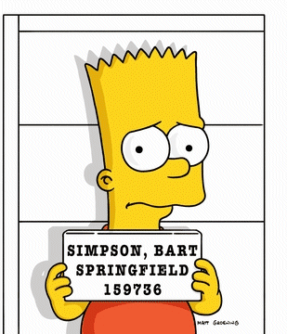
Bart has ordered some new catapults online. He has to collect them today…
- Bart needs to get to Springfield Mall to collect his catapults before lunchtime. What times can he get the bus from the Kwik-E-Mart?
- Bart needs to take the catapults to Millhouse. Millhouse will meet Bart outside Moe’s Tavern at around noon. What time does Bart need to get a bus from Springfield Mall to get the Moe’s Tavern close to noon?
- Bart and Millhouse want to use their catapults at the Elementary School during lunch. What bus must they get from Moe’s Tavern to arrive at the school at lunchtime (13:00)?
Chapter 2: Long Walk Homer

- Homer has is late for work. He needs to get from Moe’s Tavern to the Nuclear Power Plant. It’s 9:45am. What time can he get to the Nuclear Power Plant?
- Homer is supposed to collect Bart and Lisa from school. School finishes at 3pm. What bus must Homer catch from the Nuclear Power Plant?
- Finally, Homer is going out tonight for drinks at Moe’s, then in Shelbyville with Lenny. Plan out his journey, starting at the Quick-E-Mart so that he gets to Shelbyville after 8pm.
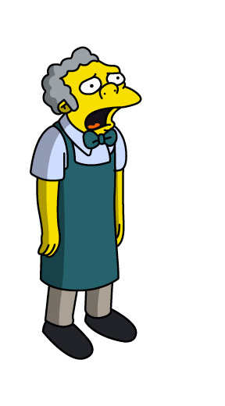
Chapter 3: Moe Money Moe Problems
- Moe has a date in Shelbyville. He’s meeting his date for lunch and a movie at 1pm. What time should he get the bus?
- He wants to be back at his Tavern in time for the football game at 5pm. Will he be able to make it back for the start of the game?
- Moe needs to collect money from Lenny. Plan a trip to the nuclear power plant to meet Lenny for lunch (between 12 and 1) and be back before 2pm
Springfield Timetables (Medium – Hard)
Elementary School | 08:30 | - | - | - | - | - | - | - | 22:10
Moe’s Tavern | 08:50 | 09:30 | 11:00 | 13:00 | 14:30 | 15:!5 | 18:00 | 20:30 | 22:30
Nuclear Power Plant | - | 10:05 | 11:35 | 13:35 | 15:05 | 15:50 | 18:35 | 21:05 | 23:05
Kwik-E-Mart | 09:40 | - | 11:55 | 13:55 | - | - | 18:55 | 21:25 | 23:30
Springfield Mall | 09:55 | - | - | 14:05 | - | - | - | - | -
Shelbyville | 10:15 | 10:45 | 12:45 | 14:25 | 15:45 | 16:30 | 19:40 | 22:35 | -
Shelbyville | 8:45 | 9:45 | 10:45 | - | - | 13:25 | - | 16:45 | -
Springfield Mall | 9:05 | 10:05 | 11:05 | - | 11:40 | - | 15:40 | 17:05 | 19:40
Kwik-E-Mart | 9:20 | 10:20 | 11:20 | - | 11:55 | - | 15:55 | 17:20 | 19:55
Nuclear Power Plant | - | - | - | 11:55 | 12:15 | 13:55 | 16:15 | - | 20:15
Moe’s Tavern | 10:10 | 11:10 | 12:10 | 12:30 | 12:45 | 14:30 | 16:45 | 17:10 | 20:45
Elementary School | 10:30 | 11:30 | 12:30 | - | 13:00 | 14:45 | 17:00 | 17:30 | 21:00

Chapter 4: Send In The Clowns
Krusty is trying to promote his new TV Show

- Krusty needs you to organise his promotion tour of Springfield. Write him a timetable that will take him to each of the bus stops on the timetable except Shelbyville, making sure he stops at the Springfield Mall for lunch (any time between 12 and 2pm)
- Krusty left his wallet at the nuclear power plant. He’s not sure if it’ll still be open. Moe tells him that he knows it closes just after the last bus to the
Kwik-E-Mart. What time does the nuclear power plant close?
- Krusty decides he’ll go back for his wallet. He gets the 22:30 bus from Moe’s Tavern to the Nuclear Power Plant. Apu tells him he can give him a lift home if he gets to the Kwik-E-Mart by 11:30pm. Krusty thinks he can make it, but Moe says he can’t. Why can’t he?
Chapter 5: Maggie May… Or May Not!
- Marge is trying to get Maggie to nursery on time. The nursery is next to Springfield Mall. Marge arrives at Moe’s Tavern at 9am. She looks at the timetable and realises she can’t get another bus to the mall until 1pm. Moe tells her she can get to the mall for 11:05. How can she?
- Marge decides to go for a walk around town. It will take her 145 minutes to walk from Springfield Mall to Bart’s school. It’s 11:45am. If Marge sets off now, what time will she arrive at the school?
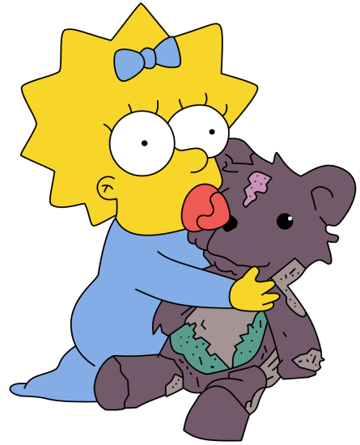
- Selma is also going to the school, She sets off from Shelbyville at 10:45 but stops at the Quik-E-Mart for 20 minutes. How long will it take Selma to get from Shelbyville to the school?

